Project Design Phase-II

Data Flow Diagram & User Stories

|  |  |
| --- | --- |
| Date | 14 October 2022 |
| Team ID | PNT2022TMID37038 |
| Project Name | Project - A Gesture-Based Tool for Sterile Browsing of Radiology Images |
| Maximum Marks | 4 Marks |

# Data Flow Diagrams:

A Data Flow Diagram (DFD) is a traditional visual representation of the information flows within a system. A neat and clear DFD can depict the right amount of the system requirement graphically. It shows how data enters and leaves the system, what changes the information, and where data is stored.

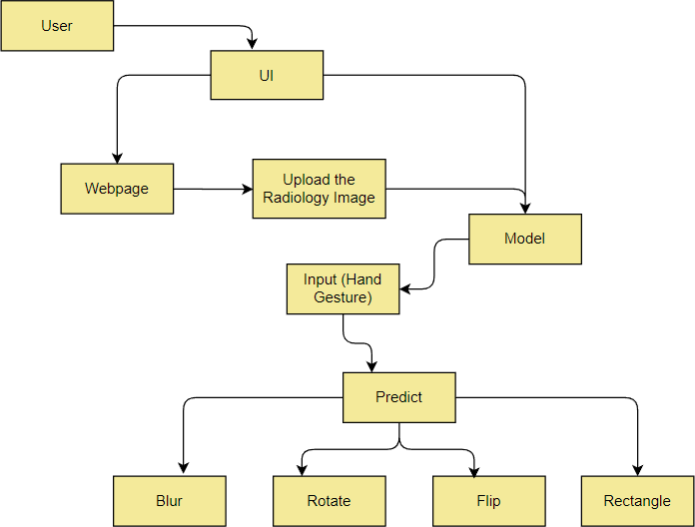

# User Stories

Use the below template to list all the user stories for the product.

|  |  |  |  |  |  |  |
| --- | --- | --- | --- | --- | --- | --- |
| **User Type** | **Functional Requirement (Epic)** | **User Story Number** | **User Story / Task** | **Acceptance criteria** | **Priority** | **Release** |
| Customer | Login | USN-1 | Entering Webpage | I can enter the application | High | Sprint-1 |
|  | Homepage | USN-2 | Entering to the “Homepage” of the UI(Webpage) | I can enter the homepage | High | Sprint-1 |
|  | About | USN-3 | I can click on the “About” to details about the Application | I can get a Details about the Application | Low | Sprint-2 |
|  | Begin | USN-4 | As a user I can upload my radiology image  from the computer. | I can choose any image  from my device | High | Sprint-2 |
|  | Predict | USN-5 | As a user I can turn on the camera using predict button | I can tun on cameras for prediction | High | Sprint-3 |
|  |  | USN-6 | Predicting the images using Hand Gesture | I can resize, blur, and flip  my image using my hand gesture | High | Sprint-3 |
|  |  | USN-7 | I can give a gesture of raised fist and it  recognizes | I can get my fixed resized  image | High | Sprint-4 |
|  |  | USN-8 | I can show my index finger | I can get a rectangular image | High | Sprint-4 |
|  |  | USN-9 | I can show my index finger, middle finger and ring finger at once | I can get my image blurred | High | Sprint-4 |